**ITMD 510 Initial Draft Requirements**

|  |  |
| --- | --- |
| **S.No** | **INDEX** |
| 1 | Team Name and Group Size |
| 2 | Introduction |
| 3 | Why are you developing this project |
| 4 | Expected outcomes |
| 5 | Technologies Used (Front-End and Back-End) and Domain |
| 6 | Initial High-level architecture |
| 7 | ER Diagram |
| 8 | UML Diagram |
| 9 | MVC Model |
| 10 | Documentation |

**E-Health**

Version No. : 1.1

Date: 4/03/2019

Project Name: E-Health– Drugs Predicting System

Presented by

Parth Kaushik – A20417447

Hiren Jagani – A20432602

**INTRODUCTION**

E-Health is a Java stand-alone application which can predict salts/Drugs on the basis of different problems patient faces like cold-cough, skin problems, Headache etc. System provide Good GUI according to which System analyzed different health issues and after analyzing these issues it can predict drugs , Here we also provide Dr. portal such that Dr. able to see patient report and predicted medicines according to their patient id generated.

It might have happened so many times that we need Doctor Help immediately, but they are not available due to some reason. The “E-Health System Using Data Mining” is an end user support and online consultation project. Here We Propose System that allows users to get instant guidance on their health issues through an intelligent health care system online. The System is fed with various symptoms and the disease /illness associated with those systems. The System allows user to share their symptoms and issues .It then process users’ symptoms to check for various illness that could be associated with it and provide a salt to that problem. Thus make ease on the hand of both Doctor and Patients .Further the panel is provide with online appointment with doctor ,thus also provide doctor login to check no of patients having appointment with doctor and What System detect the cause of patient illness thus evaluation of both result provide doctor a keen knowledge to the problem of disease and on the other hand provide patient an good artificial doctor interface any time when they needed .

**Why are you developing this project?**

Since day by day as our population is increasing there must be a need of health satisfaction as more population result to more EPIDEMIC therefore a health hazard will occur if there is no proper treatment of diseases , thus to handle a large no of people there must be a skilled

Doctors required to treat them and provide them basic amenities and appurtenant for their habitat. But it is merely possible thus there is a need of system which act as doctor and prescribe patients a good treatment. Thus in this project we develop “E-Health System” and we reach to conclusion by taking different data from people, thus obtain valuable knowledge from knowledge data base of System. This project is design under Maven –

Spring framework and coding is done under Object Oriented Language i.e. ‘Java’.

**Expected outcomes**

1. Fast Track Facilities

It might have happened so many times that we need doctor help immediately, but they are not available due to some reason This application helps both Doctor and Patients to speed up their process at their own ends. Impair Patients who waits for long time to get impairment certificate from Hospital can get it more easily than and as fast as possible and by default provide a support for tele medicines. The E Health System is an end user support and online consultation project. System through an intelligent approach can solve problems at fast pace with easy approach. The system allows user to share their symptoms and issues. It then process users symptoms to check for various illness that could be associated with it

Here we use some intelligent data mining techniques to get the most accurate illness that can associate with patient’s symptoms. The panel is provide with online appointment with doctor thus also provide doctor login to check no of patients having appointment with doctor.

1. Reduce waiting times in Hospital.
2. Doctor Patient interaction time reduce.
3. Prediction of salts up to best accuracy.

**Technologies Used (Front-End and Back-End) and Domain**

### Front End:

JavaFX: Software platform for creating and delivering desktop applications.

### Back End:

Microsoft SQL Server Management Studio

### Technical Requirements:

Below is the technology that was required to build this project

Java

JavaFX

Oracle Database or MySQL

### Domain Knowledge Requirements

Health Care System or Medical Consultation system or Hospital appointment consultation, Image recognition, Predictive Analytics

### Tools Used:

Java Eclipse EE Neon

Microsoft SQL Server Management studio.

**Initial High-level architecture**

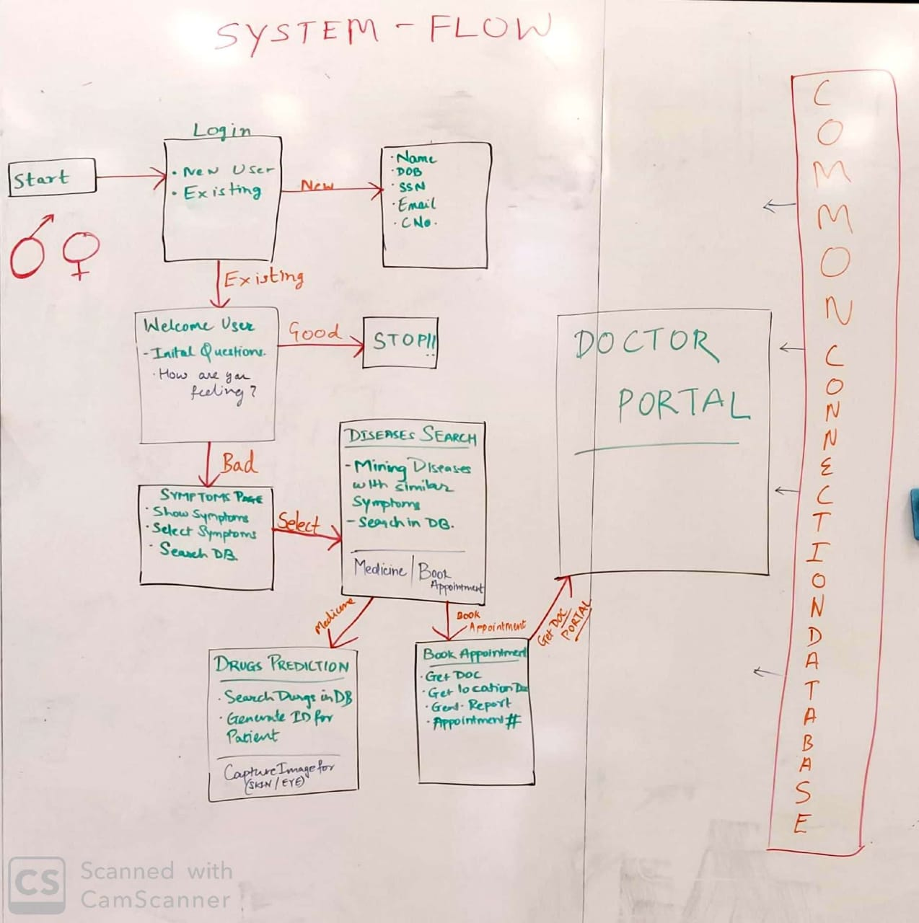

**ER Diagram**

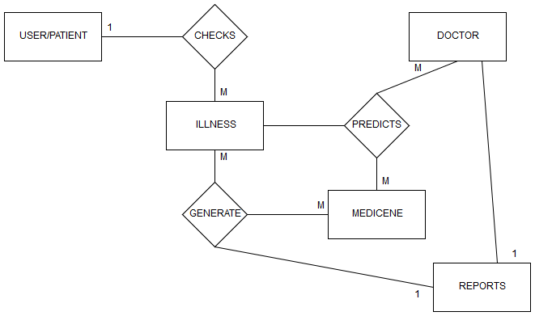

**UML Diagram**

